Age Groups: This is how the groups are organized at all competitions:
Competitive age groups are all based on the birth year, not the day:

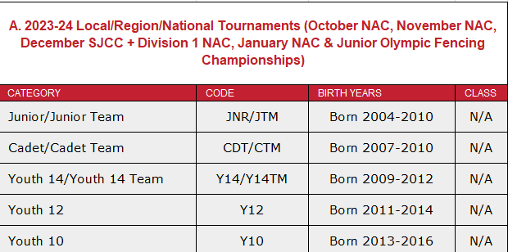
- Cadet and Juniors CHANGE after Junior Olympics
USFA Membership
Multi-club local competitions require ACCESS membership is $29
Competitive Membership ($99) is required for regional and national events (RYC’s RJCC’s, SYC’s NAC’s)
If you need to upgrade membership – log in and upgrade the membership.
Search for your membership: https://member.usafencing.org/search/members
Sign in: http://www.usafencing.org/membership. You can sign in with your membership number and say you don’t have your password! Once complete – print out your card from the website.
Once you have your competition membership for USFA, print out your card from the website. They no longer send out cards to you. You go into ACCOUNT to do that. You will need to have a copy of your card info on your phone to scan for most competitions.

How you register for LOCAL competitions: askfred.net
https://askfred.net
Askfred.net is a website that allows people to register for local regional events. You will first need to set up an account and profile. You will need your USFA # for this. Your rating is U – unrated – and the system defaults to that. Make sure to put in Vivo Fencing Club for your associated club.
Your Division is New England.
Once you have set up a profile – you can preregister and pay for the competition. You need to do this online. NOTE THE CLOSING DATES on the spreadsheet we provide – it is keep updated and posted here:
https://bit.ly/VivoCompetitiveSchedule

How to register for REGIONAL and NATIONAL competitions:
https://member.usafencing.org/search/tournaments
Type in the name of the competition or some identifying element of it. You will find the info and then on the top right there is an ORANGE square to get you to SIGN IN in order to register. Scroll down to the events that you want to register for. Click and add your name and check out. You will be able to easily see your list of registrations every time you log in.
We have added the links to the competitions listed on Vivo’s competition sheet. You can find that online at https://bit.ly/VivoCompetitiveSchedule

FAQ’s:
What does registration open date mean?
This is the date that you can start to register for a competition. In this day of limited competition event size - especially with foil, it is important to register right at the start of registration.
What does close of registration time mean on the day of the competition?
This means that you need to be at the venue and check in with the bout committee before this time on the day of the competition. If you arrive after, you will not be allowed to fence. We ask that you ONE HOUR before this time – suit up and warm up to be ready to go at the close of registration. Find the Vivo group and they will help!
How much does it cost?
This varies by competition. Local competitions are usually $25-35. Regional and National competitions usually require a competition fee and a per event fee.
How does Vivo coaching work at competitions?
This is called strip coaching, as the coach will be at the strip to help the fencer. They will not be there for every bout by every fencer – but will rotate amongst the Vivo fencers participating in an event. They will make every effort to provide good coverage and support for your fencers. If the competition is within 50 miles of Vivo, the strip coaching is $30/fencer/event. We will need to have at least 5 Vivo fencers at the competition each day to provide a coach. AND if the competition requires travel, the travel costs plus a $60 food per diem are shared amongst the fencers attending. In addition, there is a $60 per fencer per event coaching fee that is paid to the coaches. We will do our best to provide an estimate ahead of the competition.
To recap:
Local Competition Strip Coaching :$30/event/fencer
Regional/National and all competitions more than 50 miles from the club: $60/event/fencer PLUS shared coach travel costs.
Where does my VIVO patch go?
Make sure to get a VIVO patch to put on your uniform jacket. Your NON-weapon upper arm on your jacket (so righty’s on left upper arm about 2-3” below shoulder.)
What equipment do I need?

- Jacket
- Knickers
- Long socks
- Mask
- Glove
- Underarm protector
- TWO Body cords
- TWO Weapons
- Lamé, if foil
- Your USFA card! Paper or on your phone
- PLEASE put your name on ALL equipment!

- Mask cord, if foil

How do competitions work?
There are two rounds – the first round is called POOLS. They split up the competitors in groups of 6-7 and you fence everyone in that group in a round robin – 5 touch bouts. Based on the results of the pools, each age group is listed in direct elimination brackets. Y10 fencers fence 10 points. Everyone else up to Veterans will fence 15 touch bouts – using 3 periods of 3 minutes and a minute rest between each period. Once you lose, you are out. If you keep winning – it takes longer…You can expect it to take about 3 hours, sometimes less, sometimes a bit more. Partly it depends upon how many fencers will be there.
Taking private lessons at Vivo Fencing Club.
Private lessons are included at the competitive level: 1 per week Youth Competitive level and 2 per week at the Advanced Competitive Level. These are in addition to the group classes. More lessons can be taken and are optional.
Intermediate programs group classes meet 2X a week. Private lessons are optional and are $40 for 20 minutes. If your child is planning on competing at area club competitions, we require that they sign up for private lessons. We want to prepare them properly and teach them the strategy required to be successful. This individual attention will help set them up for success. We have a separate scheduling system for this that the coaches control. They will work with you to secure times that work for you.
Private lessons allow the coaches to provide specific advice in a focused way to your fencer. They are very helpful to the fencers who are starting to compete. By signing up for private lessons – you agree to pay the lesson fees – we will add up the lessons at the end of the month and then charge you through the Zen Planner system automatically. You will receive a receipt each month.
PLEASE let us know ASAP if your plans change so that we can cancel or move the lesson for you. That will open up the slot for someone else.

